SPRINGDALE LIGHT INDUSTRIAL PARK-TURNBOW AVENUE

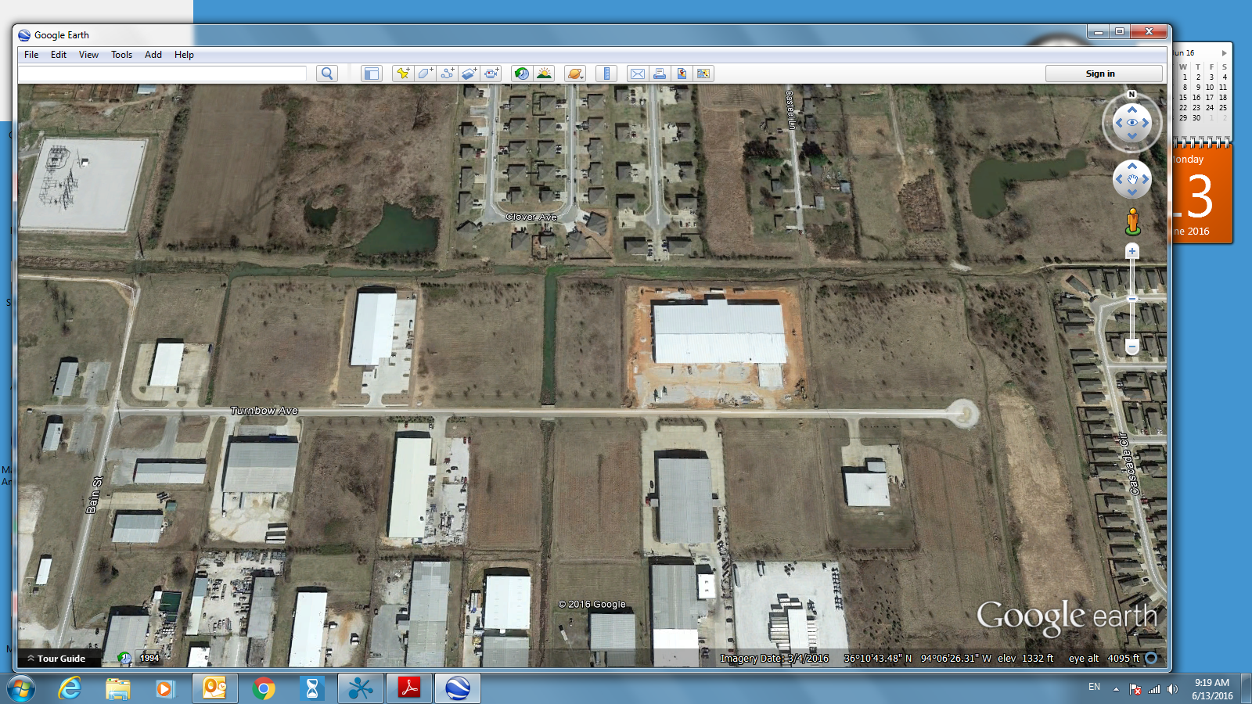
20
3
5
6
8
10
11
SOLD
12
16
17
18

